# Compounding flavors

This section describes the configuration for the main flavors of compounding that are met on the market.

Note that they can be applied also to average indices with the “Mean type”=”Built on a weighting schedule”, where the weighting schedule plays the role of the compounding schedule.

Note that even if the document is focused on IRD instruments, the same compounding flavors might be used for security finance, money market and bond products.

Correlations between typologies and compounding flavors used will be indicated below.

## Lockout

When lockout is used, a rate is crystallized and used for the following periods.

The lockout period (also called rate cut-off) is configurable in the formula definition of the compounded index.

For a lockout of n days, the–(n+1) BUSINESS DAY shifter should be used (since MX is computing the crystallized fixing from the calculation end date of the period).

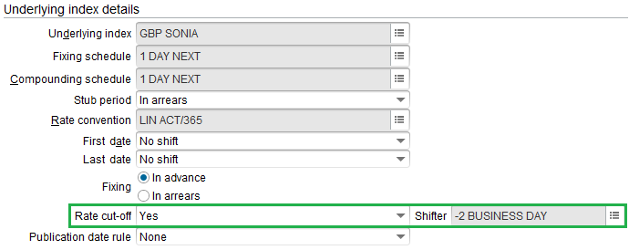

Illustration:

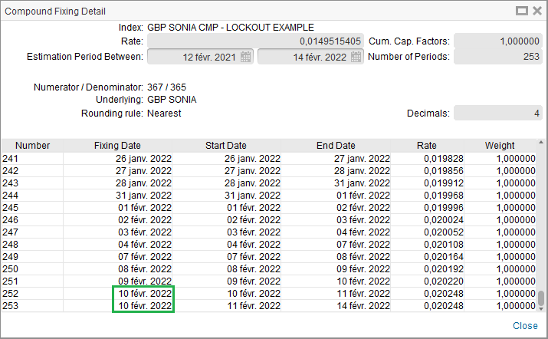

## Lookback

The fixing schedule is shifted with respect to the compounded periods (which are not affected). Generally used in bonds.

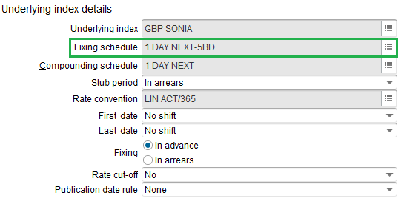

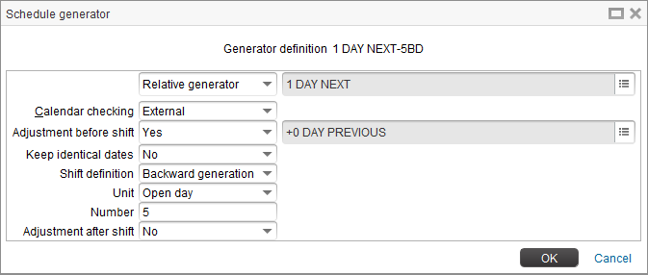

Note that the *+0 DAY PREVIOUS* adjustment has been added to properly handle the case when the compounding start date is falling on a holiday.

Illustration:

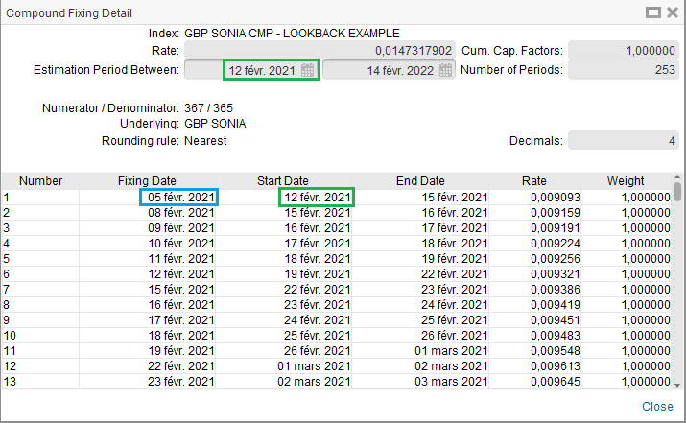

Green date (12 Feb 2021) is the calculation start date.

Blue date (05 Feb 2021) is the calculation start date adjusted by -5 BUSINESS DAY.

Note that to replicate the same lookback flavor on average indices, the “Built on a weighting schedule” mean type should be used (and 1 BUSINESS DAY schedule is used instead):

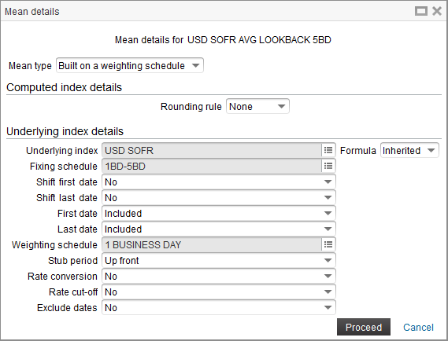

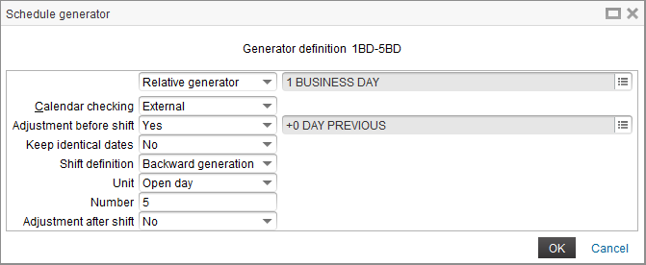

## Observation shift

The fixing schedule and the compounding schedule are both shifted.

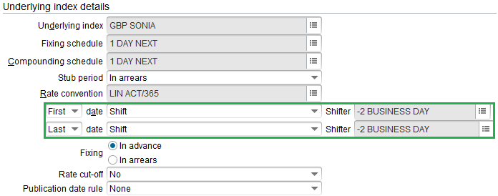

Illustration:

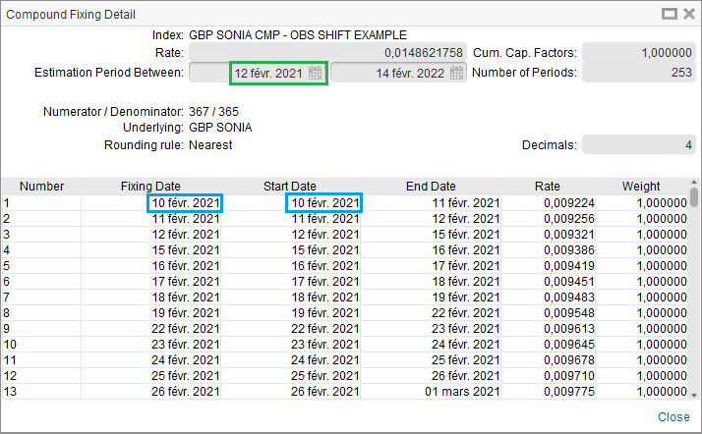

Green date (12 Feb 2021) is the calculation start date.

Blue date (10 Feb 2021) is the calculation start date adjusted by -2 BUSINESS DAY.

## Recap matrix

The following table sums up all possible combinations of the 3 flavors presented above, for compounded indices:

|  |  |  |  |  |  |
| --- | --- | --- | --- | --- | --- |
| **Index configuration** | Fixing schedule | Compounding schedule | Shift first date | Shift last date | Rate cut-off |
| **LOOKBACK x day** | 1 DAY NEXT - x BD | 1 DAY NEXT |  |  |  |
| **OBSERVATION SHIFT y day** | 1 DAY NEXT | 1 DAY NEXT | -y BUSINESS DAY | -y BUSINESS DAY |  |
| **LOCKOUT z day** | 1 DAY NEXT | 1 DAY NEXT |  |  | -(z+1) BUSINESS DAY |
| **LB + OS** | 1 DAY NEXT - x BD | 1 DAY NEXT | -y BUSINESS DAY | -y BUSINESS DAY |  |
| **LB + LO** | 1 DAY NEXT - x BD | 1 DAY NEXT |  |  | -(x+z+1) BUSINESS DAY |
| **OS + LO** | 1 DAY NEXT | 1 DAY NEXT | -y BUSINESS DAY | -y BUSINESS DAY | -(z+1) BUSINESS DAY |
| **LB + OS + LO** | 1 DAY NEXT - x BD | 1 DAY NEXT | -y BUSINESS DAY | -y BUSINESS DAY | -(x+z+1) BUSINESS DAY |

A similar table has been built below for average indices, knowing that:

- The case where fixing schedule is different from compounded schedule can be replicated for average indices by setting the mean type to “Built on a weighting schedule”, the weighting schedule playing the role of the compounding schedule

- First date/Last date settings should always be set to “Included”

|  |  |  |  |  |  |  |
| --- | --- | --- | --- | --- | --- | --- |
| **Index configuration** | Mean type | Fixing schedule | Shift first date | Shift last date | Weighting schedule | Rate cut-off |
| **LOOKBACK x day** | Built on a weighting schedule | 1 BUSINESS DAY - x BD |  |  | 1 BUSINESS DAY |  |
| **OBSERVATION SHIFT y day** | Automatically weighted | 1 BUSINESS DAY | -y BUSINESS DAY | -y BUSINESS DAY |  |  |
| **LOCKOUT z day** | Automatically weighted | 1 BUSINESS DAY |  |  |  | -(z+1) BUSINESS DAY |
| **LB + OS** | Built on a weighting schedule | 1 BUSINESS DAY - x BD | -y BUSINESS DAY | -y BUSINESS DAY | 1 BUSINESS DAY |  |
| **LB + LO** | Built on a weighting schedule | 1 BUSINESS DAY - x BD |  |  | 1 BUSINESS DAY | -(x+z+1) BUSINESS DAY |
| **OS + LO** | Automatically weighted | 1 BUSINESS DAY | -y BUSINESS DAY | -y BUSINESS DAY |  | -(z+1) BUSINESS DAY |
| **LB + OS + LO** | Built on a weighting schedule | 1 BUSINESS DAY - x BD | -y BUSINESS DAY | -y BUSINESS DAY | 1 BUSINESS DAY | -(x+z+1) BUSINESS DAY |

## Case of compounding/averaging starting on holiday

With the configurations defined above, we will get the correct rate even if the compounding start date is falling on a holiday.

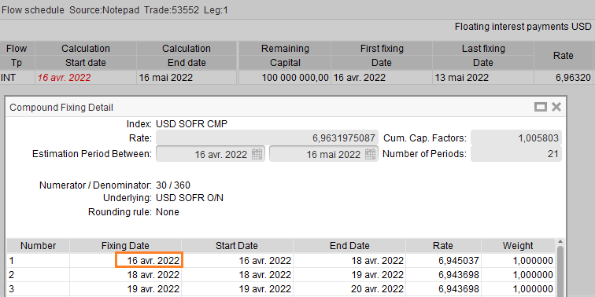

The first underlying fixing date is falling on this holiday, but as expected it will be estimated as the previous business day fixing (cf. remark on +0 DAY PREVIOUS in the previous section) and will inherit the last known fixing value when fixed, therefore also the previous business day fixing value.

However, the auto-fixing procedure will not be able to fix this flow, since there is no published rate on this holiday in the archiving group, and user can only fix the trade manually, which could cause some exception management.

To overcome this, we propose to replace **the fixing schedule** with the following configuration:

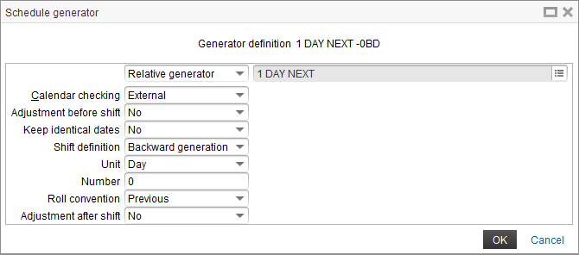

Note that using this fixing schedule for usual compounding instead of 1 DAY NEXT will have no effect on deals starting on a business day.

Similarly for average indices, we can use the same adjusted fixing schedule instead of 1 BUSINESS DAY:

